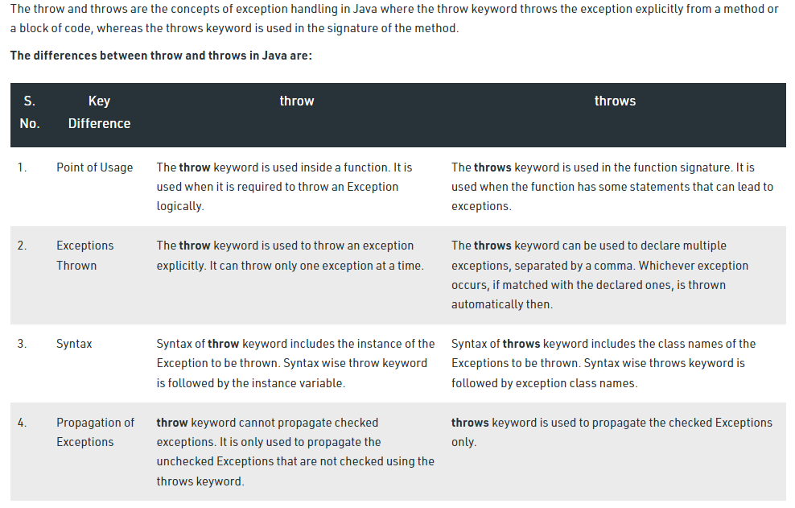

public class TestThrow {

//defining a method

public static void checkNum(int num) {

if (num < 1) {

throw new ArithmeticException("\nNumber is negative, cannot calculate square");

}

else {

System.out.println("Square of " + num + " is " + (num\*num));

}

}

//main method

public static void main(String[] args) {

TestThrow obj = new TestThrow();

obj.checkNum(-3);

System.out.println("Rest of the code..");

}

}

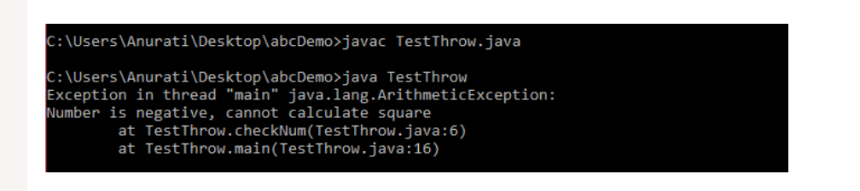

public class TestThrows {

//defining a method

public static int divideNum(int m, int n) throws ArithmeticException {

int div = m / n;

return div;

}

//main method

public static void main(String[] args) {

TestThrows obj = new TestThrows();

try {

System.out.println(obj.divideNum(45, 0));

}

catch (ArithmeticException e){

System.out.println("\nNumber cannot be divided by 0");

}

System.out.println("Rest of the code..");

}

}

